**GIMNASIO LOS PIRINEOS**

**“EDUCACIÓN Y FORMACIÓN INTEGRAL CON ENFASIS EN VALORES, INGLÉS, EMPRENDIMIENTO Y GESTIÓN LABORAL”.**

**TALLER III PERIODO**

**ENGLISH 9°**

ESTUDIANTE: ____________________________________ FECHA: __________________________

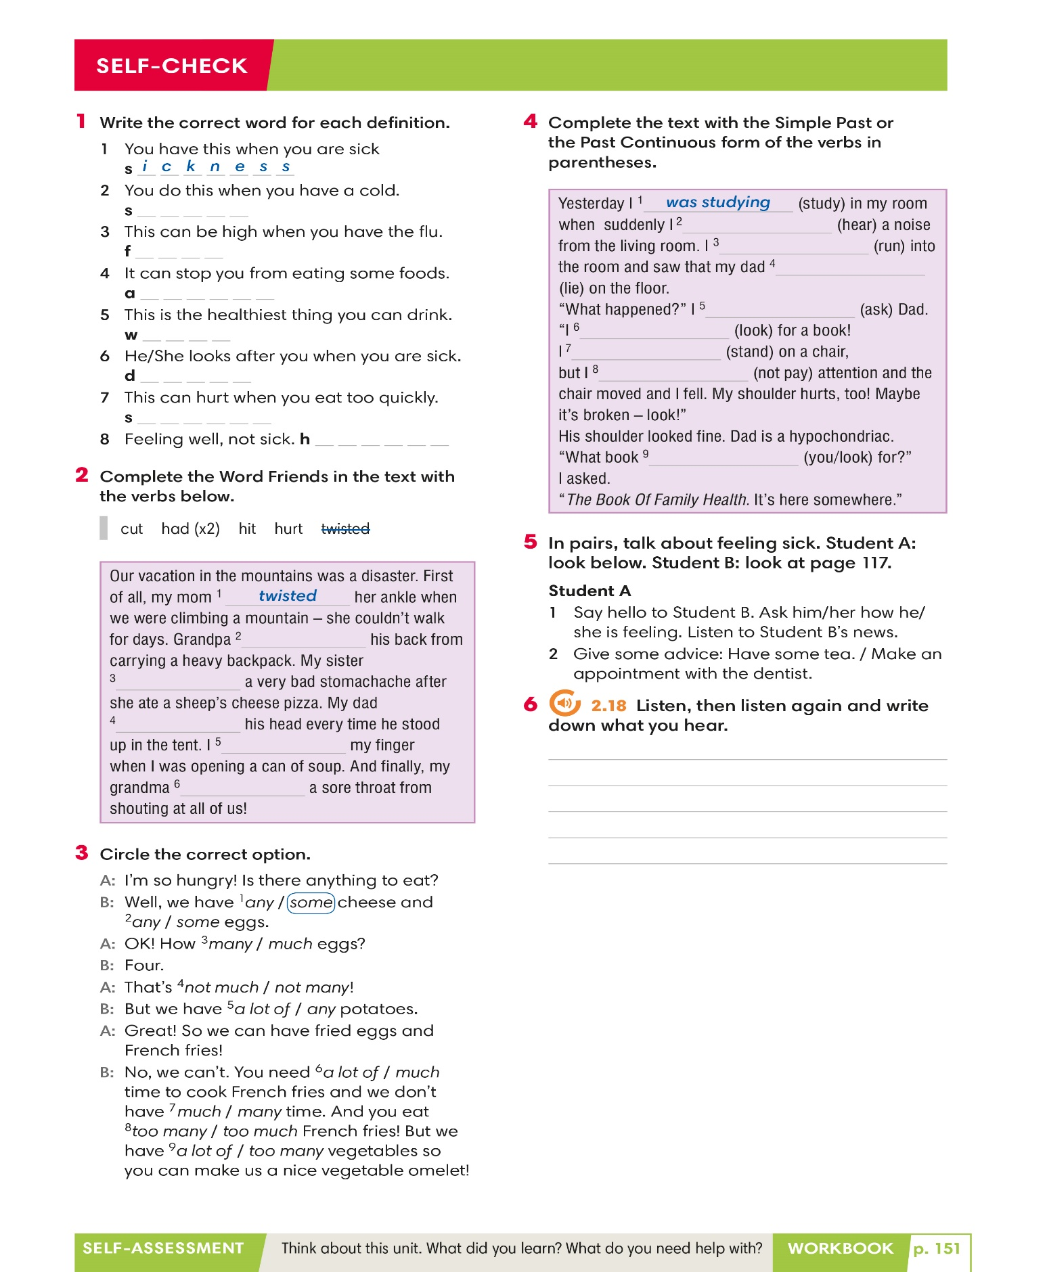

Parts of the body

**Find the words in the word snakes. Write them in the correct place.** 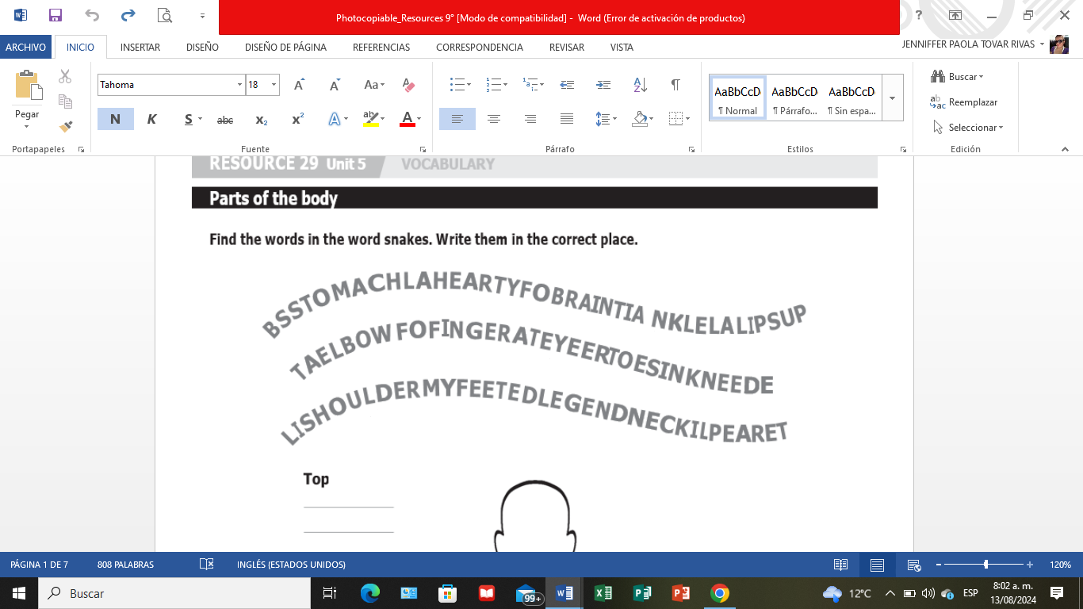

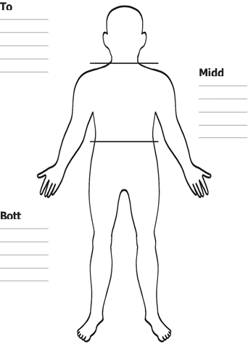

**Talk about habits**

**Section A**

1. **Complete the questions with one word in each blank.**
   1. Do you often tired during the day?
   2. How often do you asleep in front of the TV?
   3. What do you do to ready for bed?
   4. What time do you to bed on a school night?
   5. Do your parents you up on Saturdays and Sundays?
   6. Do you well the night before an important test?
   7. Do you stay late on Friday evenings?
   8. Did you a dream last night? Can you remember it?

**Section B**

1. **Complete the questions with one word in each blank.**
   1. Do you ever bad dreams? Can you remember one?
   2. How long do you in bed on a Saturday morning?
   3. Do you more sleepy in the morning or in the evening?
   4. How many hours do you on Saturday nights?
   5. Do you find it easy to asleep at night?
   6. Do you up quickly when you wake up or do you lie in bed for a long time?
   7. Do you asleep when you travel by car, train, or bus?
   8. Do you to bed when you are tired or only when your parents tell you to?

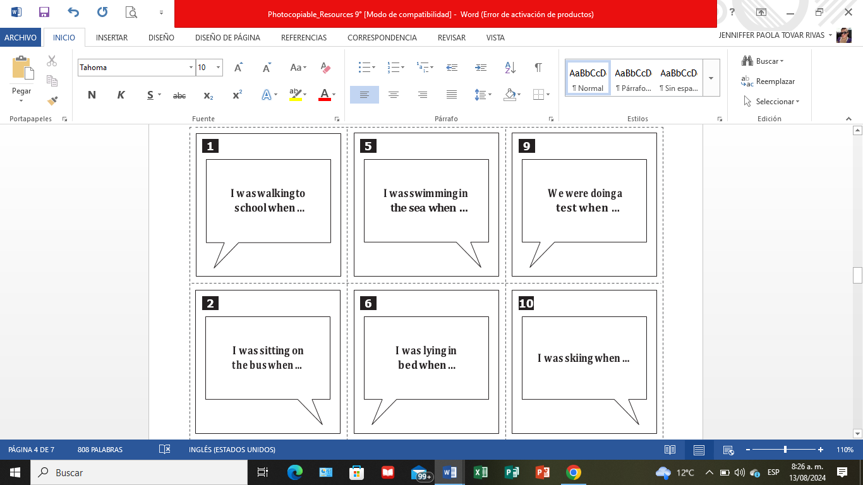

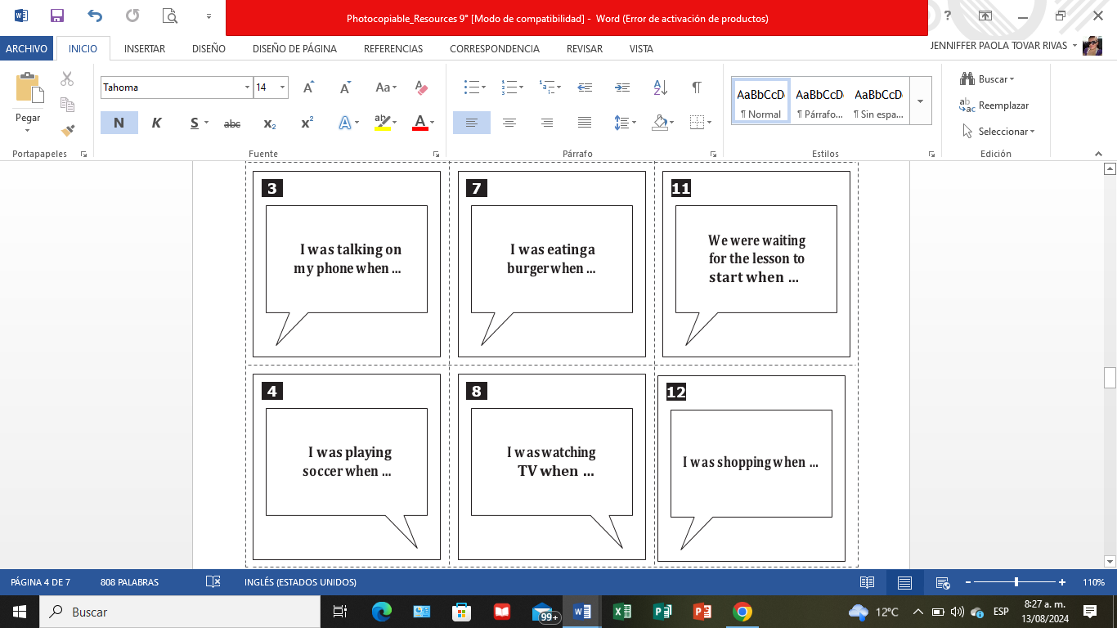

**Symptoms and illnesses**

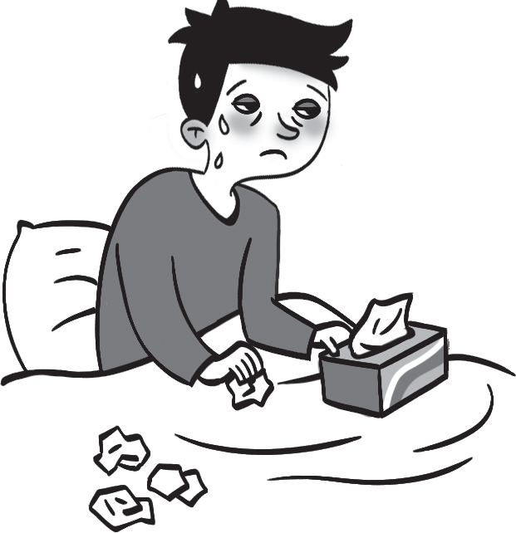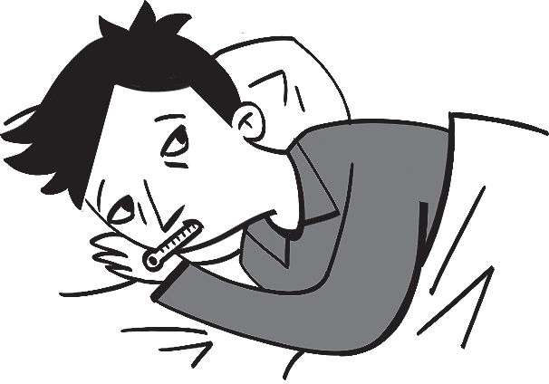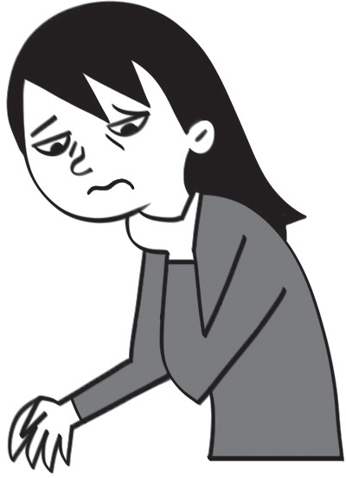 **1 4 7**

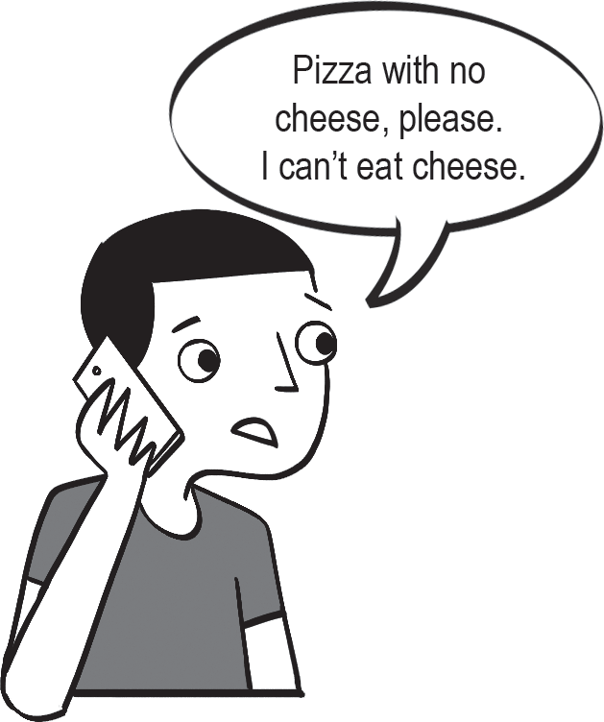 **2 5 8**

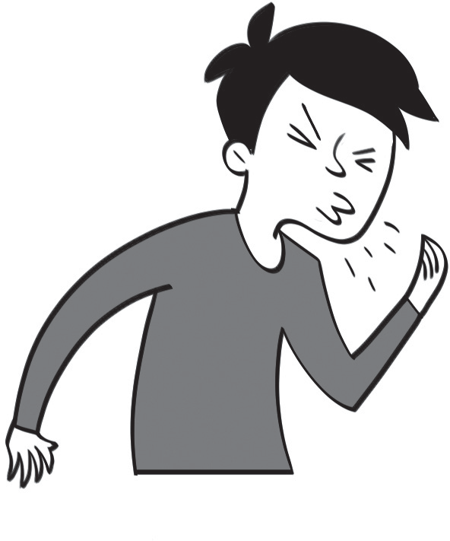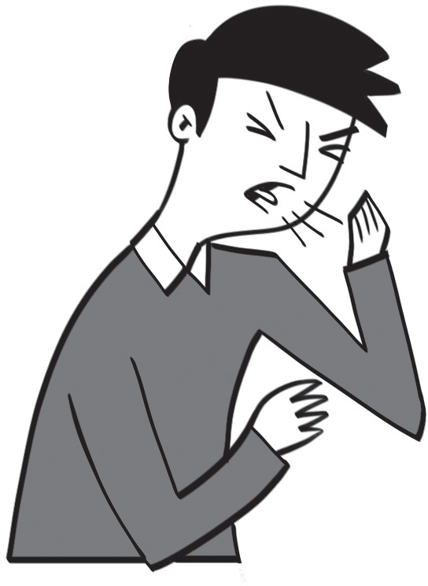

**3 6 9**

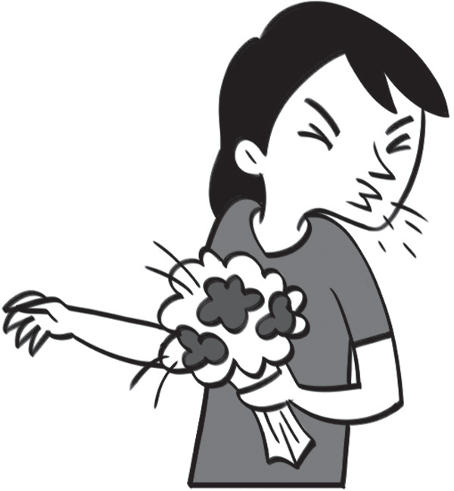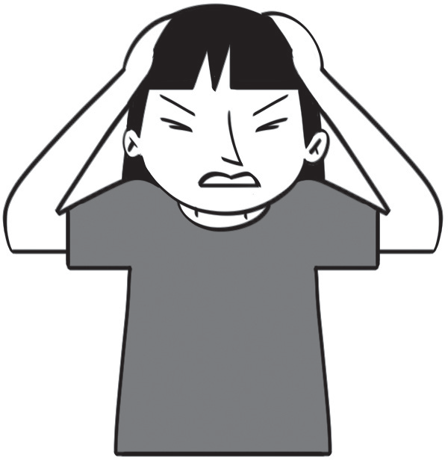 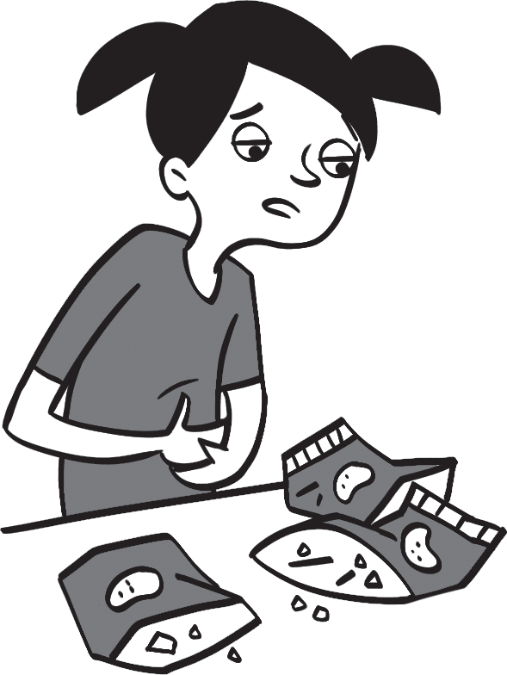

# Health and illnesses

1. **Complete the dialogues with one word in each blank.**
   1. **A:** What’s the ?

**B:** I terrible.

**A:** Do you have a stomachache?

**B:** No. I have a sore and a high .

**A:** You have some water and lie . I think you have the .

* 1. **A:** What’s ?

**B:** I have toothache.

**A:** You eat too many candies. You should an appointment with the .

* 1. **A:** How are you ?

**B:** Better, thanks. My leg a little, but it isn’t too bad. I think I’ll go for a walk.

**A:** You should in bed for another two days.

* 1. **A:** I have a headache.

**B:** You should an aspirin.

**A:** I think I should stay bed today.

**B:** Do you have an English test today?

**A:** Yes.

**B:** Are you sure you’re very ill?

**A:** Yes, it’s really bad.

**B:** Maybe we should to the hospital.

**A:** Er … no, it’s OK, Mom. I’ll be fine at home.